NOTICE
FROM: Caribbean Developments (Antigua) Ltd
TO: All Jolly Harbour Residents
DATE: February 4, 2014
SUBJECT: Water Conservation Continuation!

Dear Residents
As a follow-up from our January 3rd Notice APUA has issued a new report stating that the water levels across the Island are becoming critical, which in turn is having an effect on our supplies.
We are therefore reminding all residents to continue with making a concerted effort in conserving water and for those who can and have not yet done so, to switch over to using your cisterns.
This Water Conservation period will remind in effect until the Government of Antigua and Barbuda gives all water users the all clear.
CDAL appreciates your continued cooperation in this matter, and have listed some of APUA “Water Conversation Tips” for your reference.
You are kindly asked to be guided accordingly.

Dave Watson
Maintenance Manager

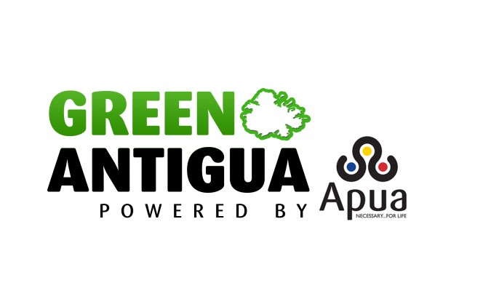

Water Conservation Tips
Water is undoubtedly one of the Earth’s most precious resources. As water consumers it is our duty to protect this life sustaining resource by conserving. Here are a few ways to maximize your water use and reduce your wastage.

Kitchen
- Repair dripping faucets by replacing washers. If your faucet is dripping at a rate of one drop per second, you can expect to waste 2,700 gallons per year.
- Do not use running water to thaw meat or other frozen foods. Defrost food overnight in the refrigerator or use the defrost setting on your microwave.
- When washing dishes by hand, fill one sink or basin with soapy water and fill another with clean water.
- Operate automatic dishwashers and clothes washers only when they are fully loaded. Set the water level for the size of load you are using.

Bathroom
- Check for toilet tank leaks by adding food coloring to the tank. If the toilet is leaking, color will appear in the toilet bowl within 30 minutes. Check the toilet for worn out, corroded or bent parts. Most replacement parts are inexpensive, readily available and easily installed. (Flush as soon as test is done, since food coloring may stain tank.)
- If the toilet handle frequently sticks in the flush position letting water run constantly, replace or adjust it.
- Install a toilet dam or displacement device such as a bag or bottle to cut down on the amount of water needed for each flush. Be sure installation does not interfere with the operating parts.
- When purchasing new or replacement toilets, consider low-volume units which use less than half the water of older models.
- Take shorter showers. In the shower, turn water on to get wet; turn off to lather up; then turn back on to rinse off. Repeat when washing your hair.
- Replace your showerhead with an ultra-low-flow version. Some units are available that allow you to cut off the flow without adjusting the water temperature knobs.
- Place a bucket in the shower to catch excess water and use this to water plants. The same technique can be used when washing dishes or vegetables in the sink.

Outdoors
- Verify that your home is leak free. Many homes have hidden water leaks. Read your water meter before and after a two-hour period when no water is being used. If the meter does not read exactly the same, there is a leak.
- A hose uses about 50 gallons of water every 5 minutes. When cleaning your driveways, sidewalks and houses, use a broom and not a running hose.
- Never pour water down the drain when there may be another use for it such as watering a plant or garden, or for cleaning around your home. The phosphates in detergents are actually good for plants

